

BrewBalance: Starbucks Drink Insights

#### Discover your perfect Starbucks drink with this comprehensive report, showcasing nutritional insights to make your healthiest choice yet!

**Prepared By:**

Merritt Shaji

MBA – Information Technology

Contact information

Email: [merrittshaji5@gmail.com](mailto:merrittshaji5@gmail.com)

LinkedIn: www.linkedin.com/in/merrittshaji

**Table of Contents**

### Introduction

1. Background
2. Business and Market Need

### Data cleaning and Transformation

1. Fact and Dimension Tables
2. Proposed Data Warehouse
3. Dashboards and Visualizations
4. Conclusion

### Introduction

In today's dynamic business environment, data-driven decision-making is essential for maintaining a competitive edge. As consumers become increasingly health-conscious, there is a growing demand for detailed nutritional information about their favourite beverages. This report leverages Power BI to transform a meticulously cleaned and pre-processed Starbucks dataset into actionable insights, with a particular focus on nutritional analysis.

The study examines critical factors such as drink type, preparation methods, caffeine levels, calories, protein, vitamins, sugar, carbohydrates, minerals, and other nutrients to provide a comprehensive understanding of Starbucks' beverage nutrition. By standardizing data formats and establishing robust table relationships, we ensure accuracy, enabling a strategic blueprint that supports product optimization and informed decision-making. The use of interactive dashboards helps visualize trends, optimize product offerings, and align Starbucks with consumer health preferences, ultimately driving continuous improvement and market leadership.

### Background

Starbucks, a global giant in the coffee industry, traces its roots back to 1971 in Seattle, where it began as a humble roaster and retailer of whole-bean coffee. The company's trajectory took a decisive turn in the 1980s under the leadership of Howard Schultz, who envisioned transforming Starbucks into a network of coffeehouses that would offer more than just a caffeine fix. Inspired by the Italian café culture, Schultz's vision emphasized creating a "third place"—a "comfortable and inviting space between home and work where people could socialize, relax, or work. This concept, coupled with a focus on high-quality coffee and a consistent brand experience, fuelled Starbucks' rapid expansion across the United States and, eventually, the globe.

Today, Starbucks boasts a massive global presence, with over 35,000 stores in 80 countries. Its menu has expanded to include a wide array of coffee and tea beverages, Frappuccino, pastries, and other treats. The company's iconic green and white siren logo has become synonymous with coffee culture, and its mobile ordering and rewards programs have further solidified its connection with customers. While Starbucks has faced challenges, including criticism regarding labor practices, environmental impact, and market saturation, it continues to be a dominant force in the coffee industry, constantly innovating with new products and technologies to maintain its edge. This rich history and enduring popularity make Starbucks a compelling subject for analysis, offering insights into successful brand building, market dominance, and the evolving landscape of consumer preferences.

### Business and Market Need

To remain competitive and align with evolving consumer health trends, Starbucks must leverage data-driven insights to optimize its beverage offerings. A comprehensive nutritional analysis is essential to address the following key business needs:

* Consumer Preferences: Identifying trends in demand for low-sugar, high-protein, and high-caffeine beverages to cater to health-conscious consumers.
* Product Performance: Assessing the impact of different beverages on customer satisfaction and repeat purchases by analyzing nutritional attributes.
* Market Differentiation: Enhancing transparency and accessibility of nutritional information to build consumer trust and brand loyalty while maintaining a competitive edge.

### Data cleaning and Transformation

A CSV file was initially provided containing key beverage-related data, including Beverage Category, Beverage Name, and Beverage Preparation Method, along with various nutritional attributes such as Calories, Total Fat (g), Trans Fat (g), Saturated Fat (g), Sodium (mg), Total Carbohydrates (g), Cholesterol (mg), Dietary Fibre (g), Sugars (g), and Protein (g). Additionally, it included information on Vitamin A (% DV), Vitamin C (% DV), Calcium (% DV), Iron (% DV), and Caffeine (mg).

Data Cleaning and Structuring

* All duplicates and errors were identified and removed to ensure data accuracy.
* The cleaned data was structured into five tables: Nutrition, Beverage, Preparation, Vitamins, and Minerals.
* Each table was uniquely identified using a primary key, which was also used as a foreign key in the Nutrition table to establish relationships:
  + Beverage Table: Assigned a Beverage_id, linked to the Nutrition Table.
  + Preparation Table: Assigned a Preparation_id, linked to the Nutrition Table.
  + Vitamins Table: Assigned a Vitamin_id, linked to the Nutrition Table.
  + Minerals Table: Assigned a Mineral_id, linked to the Nutrition Table.

Caffeine Data Handling

* The Caffeine field contained missing and inconsistent values. To address this, a DAX measure was created to compute the average caffeine content:

Caffeine_avg = AVERAGE(Nutrition[Caffeine (mg)])

The missing values were replaced with the computed average caffeine amount of 89.52 mg.

* A new column, Caffeine_Level, was introduced in the Nutrition table using a conditional column transformation.

DAX Measures for Data Insights

* Highest Caffeine Beverage: A DAX measure was created in the Nutrition table to identify the beverage with the highest caffeine content.
* Preparation Types: A DAX measure was created in the Preparation table to determine different preparation methods.
* Beverage Count: A DAX measure was created in the Beverage table to count the total number of beverages.

Final Structured Tables and Fields

Nutrition Table

* + Total Carbohydrates (g), Total Fat (g), Beverage ID, Caffeine (mg), Caffeine Level, Calories, Cholesterol (mg), Mineral ID, Preparation ID, Saturated Fat (g), Trans Fat (g), Vitamin ID, Dietary Fibre (g), Protein (g), Sodium (mg), Sugars (g).

Beverage Dimension Table

* + Beverage, Beverage Category, Beverage ID, Beverage Count.

Preparation Dimension Table

* + Beverage Preparation, Preparation ID, Preparation Types.

Minerals Dimension Table

* + Calcium (% DV), Iron (% DV), Mineral ID.

Vitamins Dimension Table

* + Vitamin A (% DV), Vitamin C (% DV), Vitamin ID.

### Fact and Dimension Tables

* Fact Table: A fact table contains measurable quantitative data and foreign keys linking to dimension tables, facilitating analytical queries.
* Dimension Table: A dimension table contains descriptive attributes (dimensions) related to the fact data, helping to provide context for analysis.

**Fact Table:** **Nutrition Facts**

|  |  |  |  |
| --- | --- | --- | --- |
| | **Column** | | --- | | | **Description** | | --- | |
| |  | | --- | | Dietary Fibre (g) | | Amount of dietary Fiber in grams |
| |  | | --- | | Protein (g) | | Amount of protein in grams |
| |  |  | | --- | --- | | Sodium (mg) |  | | Amount of sodium in milligrams |
| |  | | --- | | Sugars (g) | | |  | | --- | | Amount of sugars in grams | |
| |  | | --- | | Total Carbohydrates(g) | | Total amount of carbohydrates in grams |
| |  |  | | --- | --- | | Total Fat (g) |  | | Total fat content in grams |
| |  |  | | --- | --- | | Beverage_id |  | | Foreign key linking to the Beverage table |
| |  |  | | --- | --- | | Caffeine (mg) |  | | Amount of caffeine in milligrams |
| |  |  | | --- | --- | | Caffeine Level |  | | Caffeine classification level |
| |  | | --- | | Calories | | |  | | --- | | Total calorie content | |
| |  |  | | --- | --- | | Cholesterol (mg) |  | | Amount of cholesterol in milligrams |
| |  |  | | --- | --- | | Mineral_id |  | | Foreign key linking to the Minerals table |
| |  |  | | --- | --- | | Preparation_id |  | | Foreign key linking to the Preparation table |
| |  |  | | --- | --- | | Saturated Fat (g) |  | | Amount of saturated fat in grams |
| |  |  | | --- | --- | | Trans Fat (g) |  | | Amount of trans fat in grams |
| |  |  | | --- | --- | | Vitamin_id |  | | Foreign key linking to the Vitamins table |
| |  |  | | --- | --- | | Caffeine_avg |  | | Average caffeine content across beverages |

This fact table stores beverages' measurable nutritional values, along with foreign keys linking to the relevant dimension tables for enriched analytical insights.

Dimension Tables:

1. Beverage Dimension

|  |  |  |  |
| --- | --- | --- | --- |
| | **Column** | | --- | | | **Description** | | --- | |
| |  | | --- | | Beverage | | |  | | --- | | Name of the beverage | |
| |  |  | | --- | --- | | Beverage_category |  | | Category of the beverage |
| |  |  | | --- | --- | | Beverage_id |  | | Primary key for beverage table |
| Beverage_Count | Number of beverages in the category |

1. Preparation Dimension

|  |  |  |  |
| --- | --- | --- | --- |
| | **Column** | | --- | | | **Description** | | --- | |
| |  |  | | --- | --- | | Beverage_prep |  | | Description of beverage preparation |
| |  |  | | --- | --- | | Preparation_id |  | | The primary key for a preparation table |
| Preparation types | Different methods of preparation |

1. Vitamins Dimension

|  |  |  |  |
| --- | --- | --- | --- |
| | **Column** | | --- | | | **Description** | | --- | |
| |  |  | | --- | --- | | Vitamin A (% DV) |  | | Daily value percentage of Vitamin A |
| |  |  | | --- | --- | | Vitamin C (% DV) |  | | Daily value percentage of Vitamin C |
| |  |  | | --- | --- | | Vitamin_id |  | | The primary key for vitamins table |

1. Minerals Dimension

|  |  |  |  |
| --- | --- | --- | --- |
| | **Column** | | --- | | | **Description** | | --- | |
| |  | | --- | | Calcium (% DV) | | Daily value percentage of Calcium |
| |  |  | | --- | --- | | Iron (% DV) |  | | Daily value percentage of Iron |
| |  | | --- | | Mineral_id | | The primary key for minerals table |

### 6. Proposed Data Warehouse

* It pulls out information from the data warehouse.
* The data is neatly organized using something called a Star Schema which can be seen below.
* A Star Schema is a widely used database architecture in data warehousing that organizes data into a central fact table containing measurable business metrics, which are linked to multiple dimension tables that store descriptive attributes, enabling efficient querying and analytical performance.
* It makes use of Fact and Dimensional Tables to help with this organization.

#### Star schema for Nutrition analysis of Starbucks

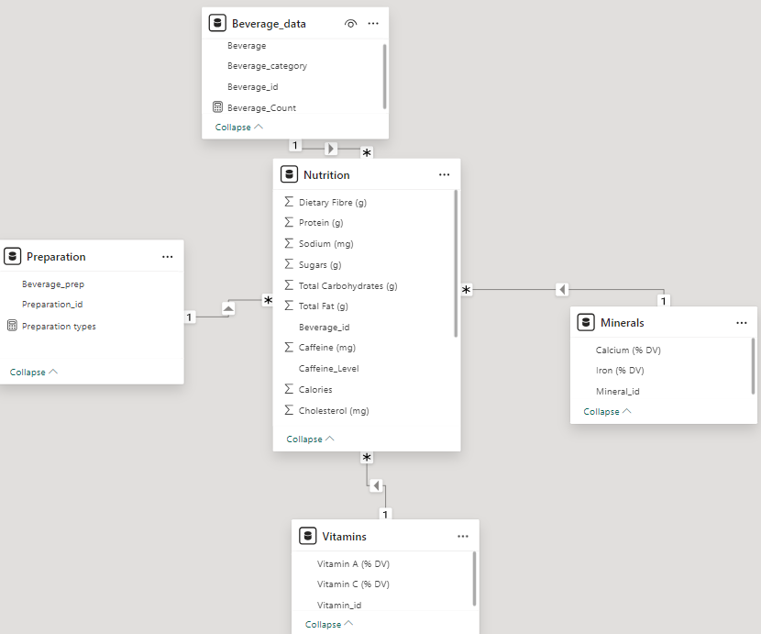

### 7. Dashboards and Visualizations

To enhance the analysis and presentation of Starbucks data, dashboards have been developed using Tableau. These dashboards will offer interactive, user-friendly visualizations of key financial metrics, making it easier for stakeholders to grasp complex data and draw actionable insights.

The Starbucks BrewBalance: Drink Insights dashboard provides valuable insights into beverage nutrition and preparation methods. Below are some key questions that can be answered using this dashboard:

Beverage Composition & Nutritional Insights

* What are the total calories, fat, carbohydrates, and sugar content of different Starbucks beverages?
* Which beverages have the highest and lowest sugar content?
* How do different beverage preparation methods impact the nutritional value?

Caffeine Analysis

* Which beverage has the highest caffeine content?
* How does caffeine level vary across different preparation methods (e.g., Grande, Venti, 2% Milk, Short)?
* What is the average caffeine content in Starbucks drinks?

Health-Conscious Choices

* Which beverages are high in protein and could be suitable for fitness-conscious consumers?
* Which Starbucks drinks are low in sugar and low in fat?
* How do different beverage categories (e.g., Espresso, Tea, Smoothies) compare in terms of nutritional value?

Beverage Trends & Preferences

* What is the total number of beverages analyzed in the dataset?
* How many preparation methods exist, and how do they differ?
* Which beverage category (e.g., Espresso, Frappuccino, Tea) is the most popular based on caffeine, protein, or sugar content?

Competitive & Business Insights

* How can Starbucks optimize its menu to meet consumer health trends?
* Which beverages should Starbucks promote or reformulate based on their nutritional content?
* How can Starbucks use this data to improve customer trust and transparency regarding nutrition?

This dashboard enables Starbucks to make data-driven decisions about menu offerings, marketing strategies, and customer preferences.

BrewBalance: Starbucks Drink Insights -Dashboard

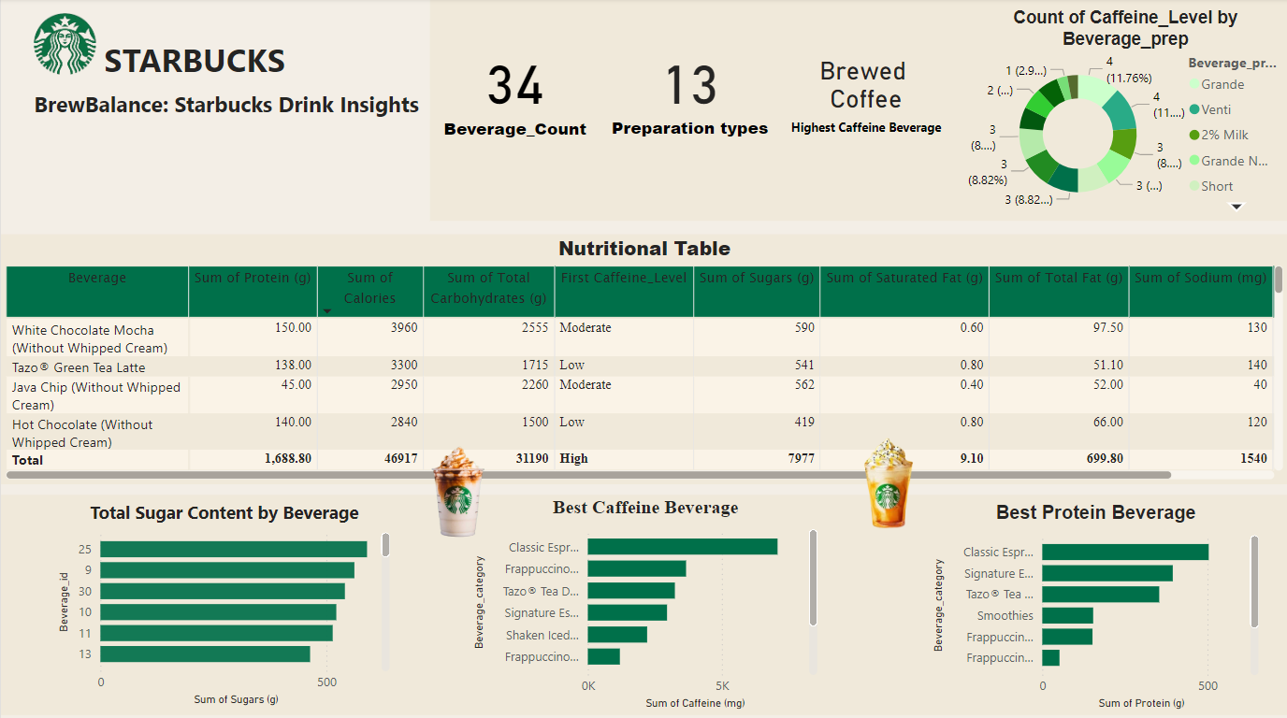

Key Metrics (Top Section)

* Beverage Count (34): Displays the total number of unique beverages available in the dataset.
* Preparation Types (13): Represents the different methods of beverage preparation.
* Highest Caffeine Beverage (Brewed Coffee): Highlights the beverage with the highest caffeine content, which is Brewed Coffee.

Count of Caffeine Level by Beverage Preparation (Pie Chart - Top Right)

* This pie chart categorizes beverages based on their caffeine level (Low, Moderate, High) and different preparation types such as Grande, Venti, 2% Milk, Short, etc.
* The chart provides insights into the distribution of caffeine content across various beverage preparation methods.

Nutritional Table (Middle Section)

* This table presents detailed nutritional information for Starbucks beverages, including:
  + Protein (g)
  + Calories
  + Total Carbohydrates (g)
  + Caffeine Level (Low, Moderate, High)
  + Sugars (g)
  + Saturated Fat (g)
  + Total Fat (g)
  + Sodium (mg)
* The total row provides aggregate values, helping analyze overall nutritional contributions.

Total Sugar Content by Beverage (Bottom Left - Bar Chart)

* This bar chart visualizes the sugar content of beverages, allowing for quick identification of drinks with higher or lower sugar levels.
* Helps in analyzing consumer preferences for high-sugar beverages and identifying healthier alternatives.

Best Caffeine Beverage (Bottom Centre - Bar Chart)

* This chart ranks beverages based on total caffeine content.
* Helps in identifying high-caffeine beverages preferred by consumers looking for an energy boost.
* The Classic Espresso appears to have the highest caffeine content.

Best Protein Beverage (Bottom Right - Bar Chart)

* Displays beverages ranked by protein content, catering to customers looking for high-protein options.
* The Classic Espresso and Signature Espresso seem to have the highest protein content, followed by Smoothies and Frappuccinos.

### 8. Conclusion

The Starbucks Nutritional Analysis using Power BI provides valuable insights into the nutritional composition of beverages, helping Starbucks optimize its menu offerings to align with consumer health trends. The implementation of a data warehouse using a star schema ensures structured, accurate, and efficient data analysis.

Key takeaways from the analysis include:

Nutritional Insights:

* + Identification of beverages with the highest and lowest sugar, fat, protein, and calorie content.
  + Understanding the impact of different preparation methods on nutritional values.

Caffeine Content Analysis:

* + Determination of the beverage with the highest caffeine content (Brewed Coffee).
  + Categorization of beverages based on caffeine levels (Low, Moderate, High).

Consumer Health Preferences:

* + Identification of high-protein beverages suitable for fitness-conscious consumers.
  + Assessment of beverages that are low in sugar and fat for health-conscious customers.

Market and Business Strategy:

* + Optimization of Starbucks' menu based on consumer demand for healthier options.
  + Increased transparency in nutritional information to build consumer trust.
  + Strategic promotion of beverages based on nutritional value.

The interactive dashboards developed using Power BI enhance data-driven decision-making by allowing stakeholders to visualize beverage trends, nutritional insights, and market opportunities effectively. By leveraging these insights, Starbucks can refine its offerings to meet evolving consumer expectations while maintaining its market leadership in the coffee industry.